Voter Persuasion Analytics Report

Project Introduction
Political campaigns always run into the same issue: there are too many voters and not enough resources to reach all of them properly. The budget is limited, the staff hours are limited, and the window before election day is short. So the question is not really whether to be selective, but how to do it in a way that is actually based on data rather than assumptions. Right now, most campaigns just target by party registration or maybe a few demographic filters, and that approach has a big flaw: it treats persuadable voters the same as people who will never change their mind no matter what message they receive. This project is trying to solve that. The dataset used here covers 10,000 registered voters and 79 variables, things like age, income, household size, party affiliation, past voting behavior, eligibility scores, and whether a voter was exposed to a specific campaign message.
Each row in the dataset is one voter, and the outcome variable MOVED_A shows whether that person was persuaded (1) or not (0). The main thing this project does is build classification models that can predict MOVED_A from the voter’s characteristics, rank all voters by their predicted persuasion probability, and also check whether the campaign message type - MESSAGE_A, actually changes outcomes across different voter groups. The point of all this is practical. The campaign needs a ranked contact list they can use when outreach starts, not just a general pool of voters sorted by party.

Business and Analytics Goals
Business Problem
The core issue is that campaign budgets are limited, but the voter pool is large and very mixed. If a campaign contacts everyone equally, a lot of that effort goes toward two groups that will not respond: voters who are already committed to a position, and voters who are simply unreachable, no matter what message they get. Targeting based on intuition, meaning using party registration or some broad demographic filter, cannot actually tell the difference between those groups and voters who are genuinely persuadable. So the campaign ends up paying the cost of all those contacts without getting a proportional return in actual persuasion.
The specific problem here is: out of 10,000 registered voters, which ones should the campaign contact first to get the best persuasion return per dollar spent? There is also a second question that interests me: does the way the message is framed (MESSAGE_A) actually affect whether someone gets persuaded, and if so, which types of voters respond to it most? Without a model, the campaign has no real basis for making either of those decisions. They are basically guessing.
Business Goals
- Improve targeting efficiency by focusing contact efforts on voters with the highest predicted persuasion probability. The aim is to capture at least 60% of all persuadable voters by only contacting the top 20% of the ranked list, instead of going through the full 10,000.
- Reduce wasted outreach by identifying voter segments that are unlikely to be persuaded and removing them from the priority contact list. The measure of success here is a top-decile lift of at least 2.0x over random targeting, meaning the highest-ranked voters should be at least twice as persuadable as a randomly selected voter.
- Determine if Message A framing (MESSAGE_A = 1) actually improves persuasion rates in a meaningful way. If it does, the campaign should use it as the default script for high-priority contacts - that is a free efficiency gain, no extra cost needed.
Each of these three goals has a direct measure in the model outputs: efficiency through decile lift, waste reduction through specificity and false positive rate, and message impact through the MESSAGE_A coefficient and persuasion rate difference between message groups.
Analytics Goals
- Build binary classification models using voter demographics, voting behavior, eligibility scores, and lifestyle indicators to produce a persuasion probability score for each voter. Without probability scores, we cannot rank voters; a simple yes/no classification is not enough for building a contact list.
- Rank all voters from most to least likely to be persuaded so the campaign has an ordered contact list to work from. This is the direct output that solves Business Goal 1.
- Evaluate all models using ROC-AUC, sensitivity, specificity, cumulative gains, and decile lift. Top-decile lift gets the most weight because the campaign’s biggest constraint is at the start of outreach, when the contact list is shortest, and each call must count the most.
- Select the model that fits both campaign needs - a ranked voter list for targeting, and a readable estimate of MESSAGE_A’s effect. The final choice needs to balance predictive performance with whether the model is actually usable in a real campaign setting.

Data Preprocessing and Exploratory Data Analysis (EDA)

Dataset Overview:
- Records: 10,000 voters × 74 variables.
- Observation unit: one voter record.
- Outcome variable: MOVED_A (0 = not persuaded, 1 = persuaded).

Main predictor groups:
- Demographics & household context (AGE, KIDS, HH_*, MED_HH_INC, MEDIANEDUC)
- Party flags and past voting behavior (PARTY_*, VPP_08, VPR_*, VG_*)
- Eligibility/propensity scores (E_PELIG, G_PELIG, PP_PELIG, AP_PELIG)
- Message exposure (MESSAGE_A and MESSAGE_A_REV)
- Lifestyle/interest indicators (BOOKBUYERI, RELIGIOUSC, POLITICALC, HEALTHFITN, etc.)
These groups map to the two business questions fairly directly. The political and behavioral variables - party, voting history, and eligibility scores - are what will predict persuadability. MESSAGE_A is what gets tested for message framing impact.
Attribute definition and data type
The raw dataset has 79 variables, so the focus was narrowed to predictors that are clearly relevant to the persuasion outcome and the campaign targeting decision. The table below covers the key ones - what each variable means, its data type, and what role it plays.
Attribute | Meaning | Data type | Role
VOTER_ID | Unique voter identifier (removed from modeling) | ID | Duplicate check only
MOVED_A | Whether voter was persuaded | Binary (0/1) | Target/label
AGE | Age of voter | Numeric (int) | Predictor
MED_HH_INC | Median household income (area) | Numeric (int) | Predictor
PARTY_D / I / R | Party flags | Binary (0/1) | Predictors
VPP_08, VPR_08/10/12, VG_04/06/08/10/12 | Past participation / voting history flags | Binary (0/1) | Predictors
E_PELIG, G_PELIG, PP_PELIG, AP_PELIG | Propensity / eligibility style scores | Numeric | Predictors
MESSAGE_A | Message A exposure | Binary (0/1) | Predictor
Note: Character variables were converted to factors before modeling. Non-numeric predictors were removed before fitting caret and glm models, keeping only the numeric predictors and the target variable.

Data quality checks and cleaning actions
Missing value analysis
- Missing values were checked at two levels. Column-by-column using colSums(is.na()) to see if any variable has systematic gaps, and row-by-row using rowSums(is.na()) to catch any voter records that would be dropped silently during model fitting. Both checks found zero missing values. No imputation was needed anywhere in the dataset.
Duplicate checks
- Duplicate rows were checked using duplicated() after removing VOTER_ID. No duplicates found - every row is a unique voter. A consistency check on the party flags was also done: PARTY_D + PARTY_I + PARTY_R summed to 0 or 1 for every voter, so no one is coded as belonging to more than one party.
Leakage / invalid variables removed
- Removed X and VOTER_ID (identifiers, not predictors).
- Removed OPP_SEX due to invalid values in the dataset.
- Removed opposite and MOVED_AD because they created data leakage.
Stability fixes before modeling
- Removed non-numeric predictors before caret modeling (kept only numeric + target).
- Removed near-zero variance predictors using caret::nearZeroVar().
- Fixed perfect collinearity by dropping one of each perfect pair (GENDER_M and MESSAGE_A_REV).
- Dropped NL* variables (NL5G, NL3PR, NL5AP, NL2PP) because they caused perfect collinearity in the models.

Visualizations
Persuasion Rate by Message Type (MESSAGE_A): MESSAGE A =1 presents a higher persuasion rate than MESSAGE A= 0, indicating message framing influences voter turnout.
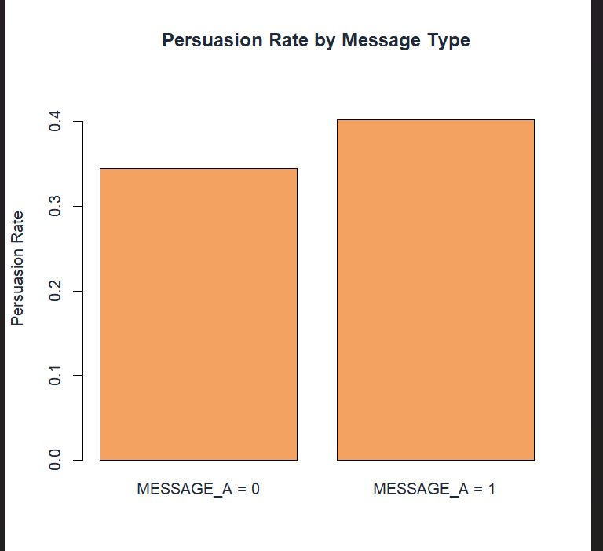
Distribution of persuasion outcome by MOVED_A: Most voters were not persuaded, indicating a clear class imbalance in the target variable.

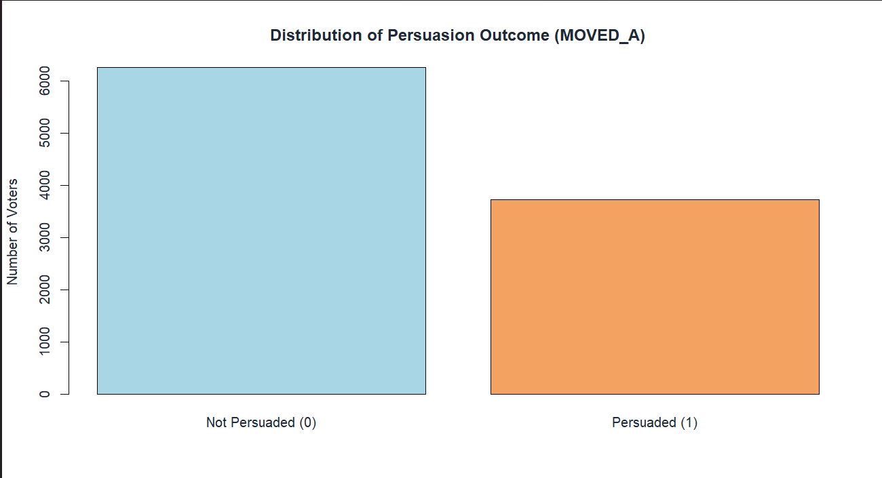
Age by Persuasion Outcome: Compare age structure between those that got persuaded and those that did not.
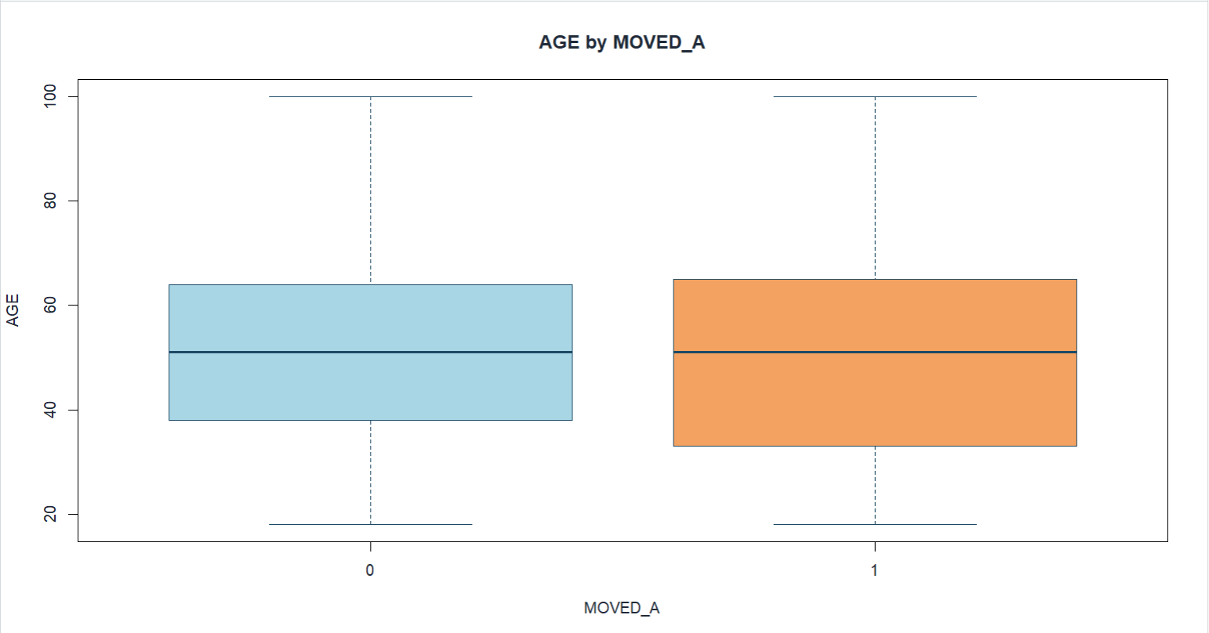
Boxplot: REG_DAYS by MOVED_A: Determine whether there is a difference in registration length depending on persuasion.
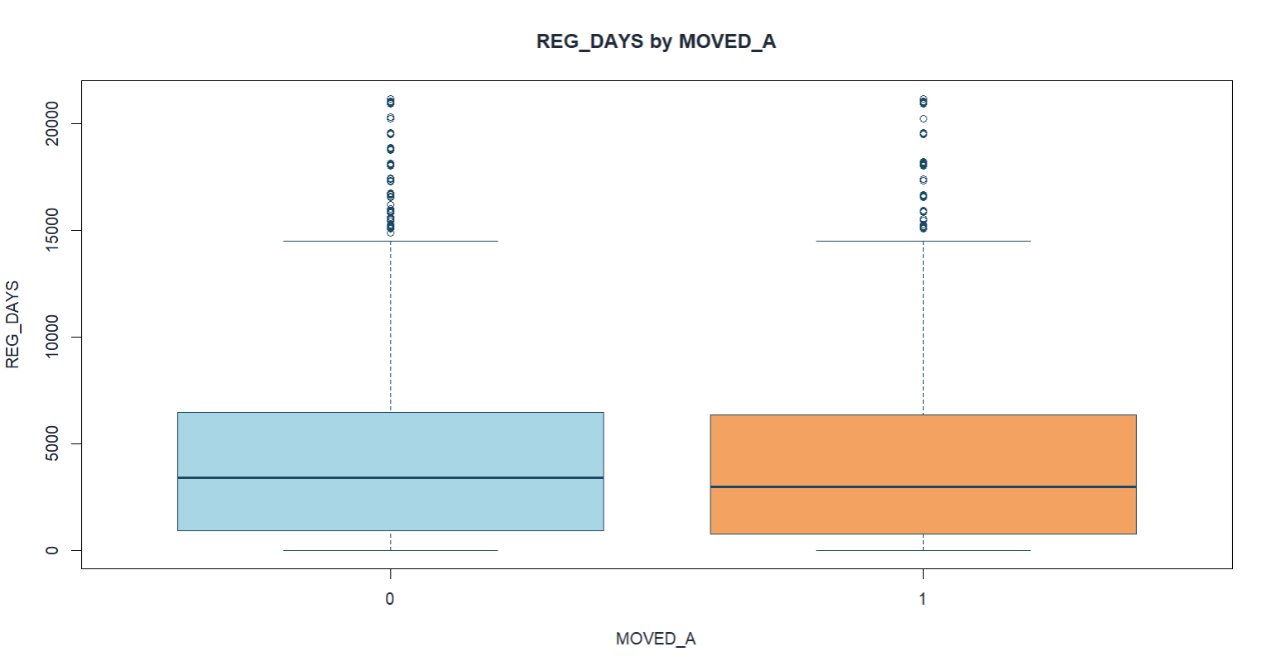
Boxplot: MED_HH_INC by MOVED_A: Income comparison across persuasion groups.
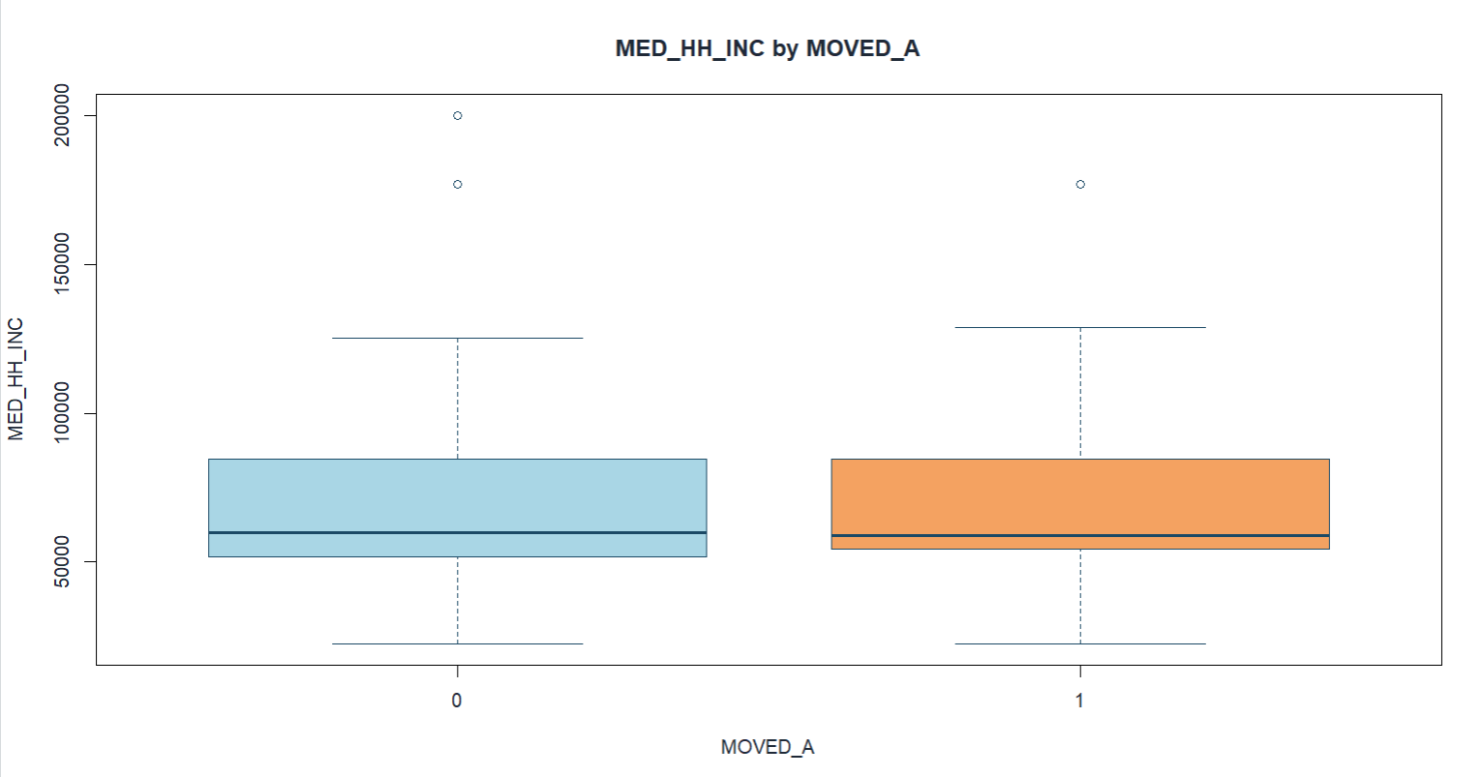

Boxplot: E_PELIG by MOVED_A: Shows eligibility signal differences.
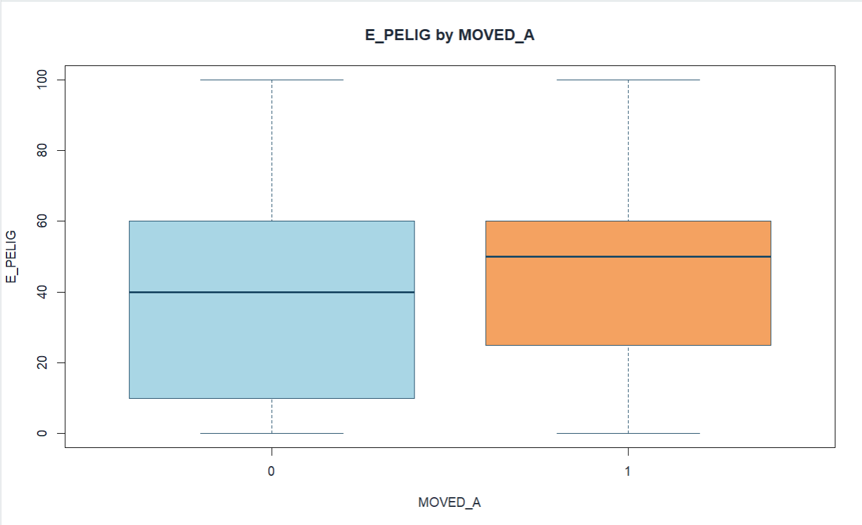
Histogram: G_PELIG: Show widespread and participation differences.
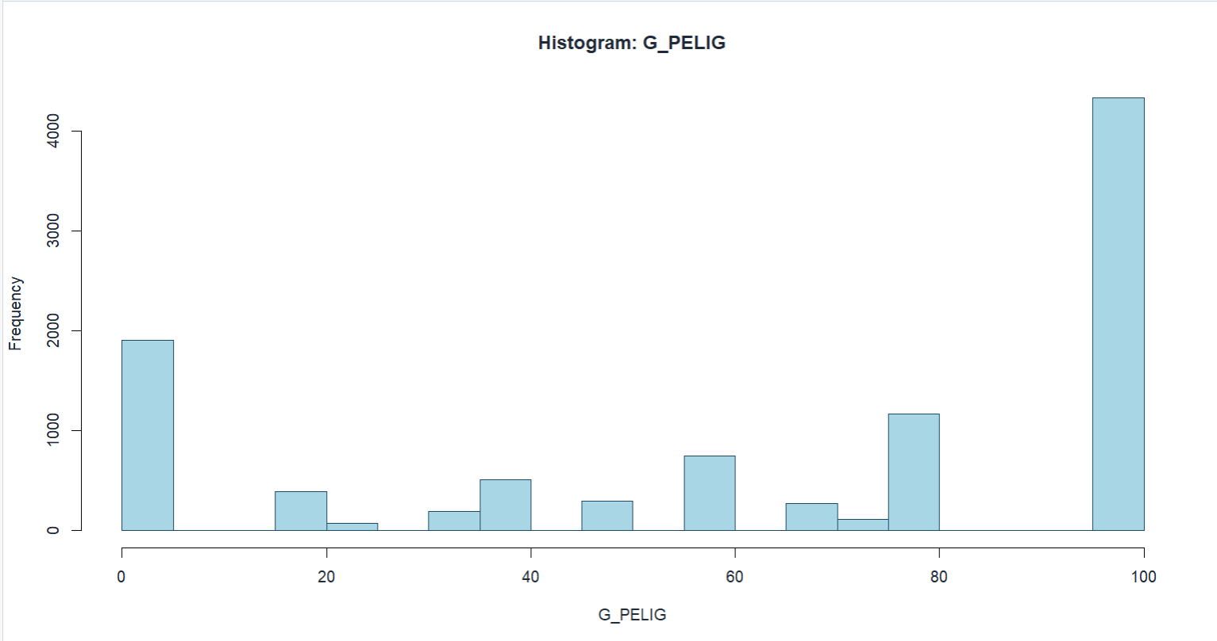
Histogram: AP_PELIG: Highlight sparse high-value outliers.
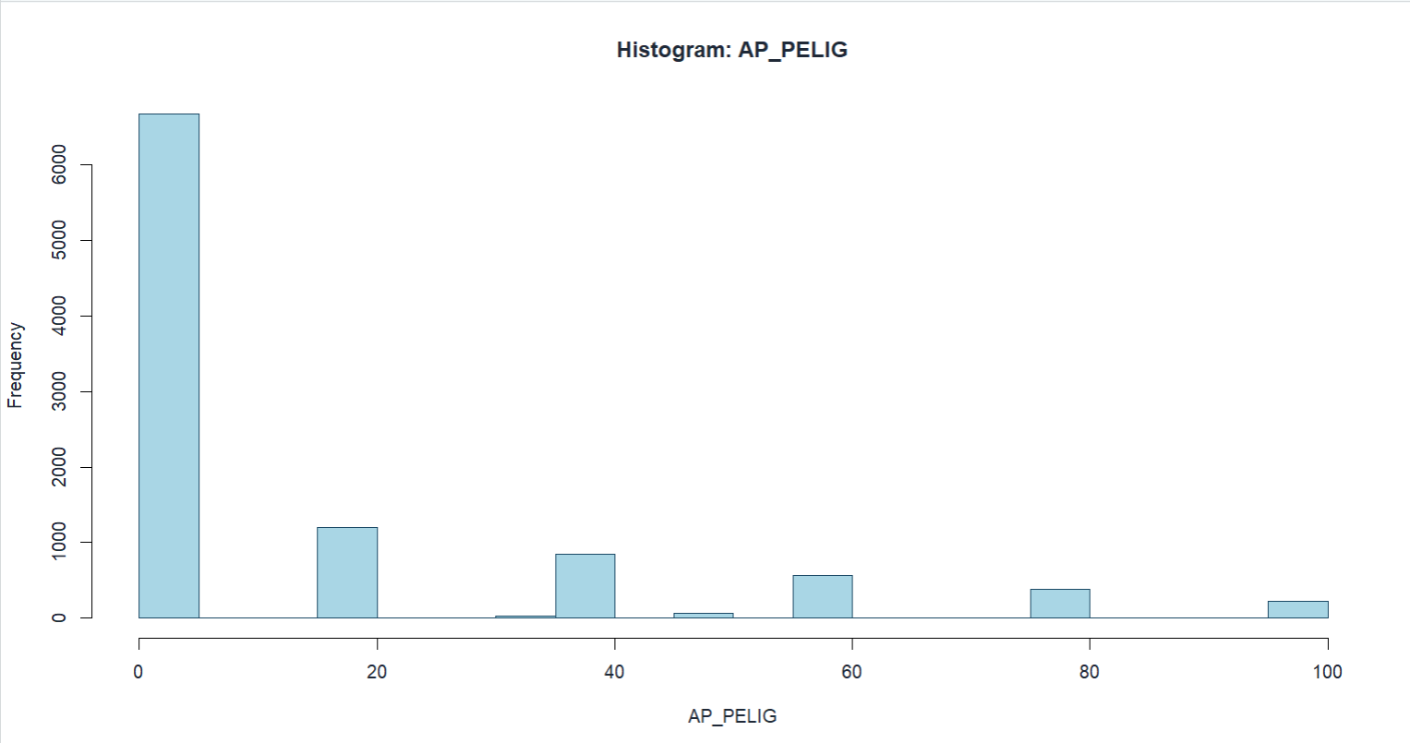
Decile Lift – Decision Tree: High lift in the top decile (~2.02) shows strong early identification of persuadable voters, with rapid decline beyond mid-deciles.
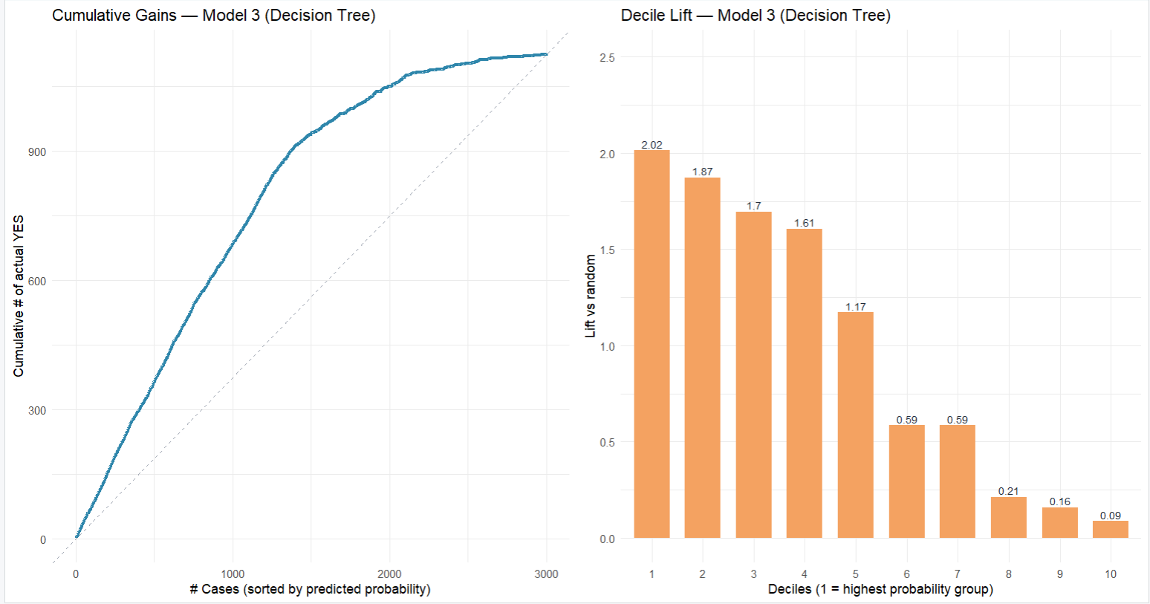

Decile Lift – Reduced Logistic Regression: Early lift (~2.01) is stable but slightly weaker, reflecting consistent ranking with simpler structure.

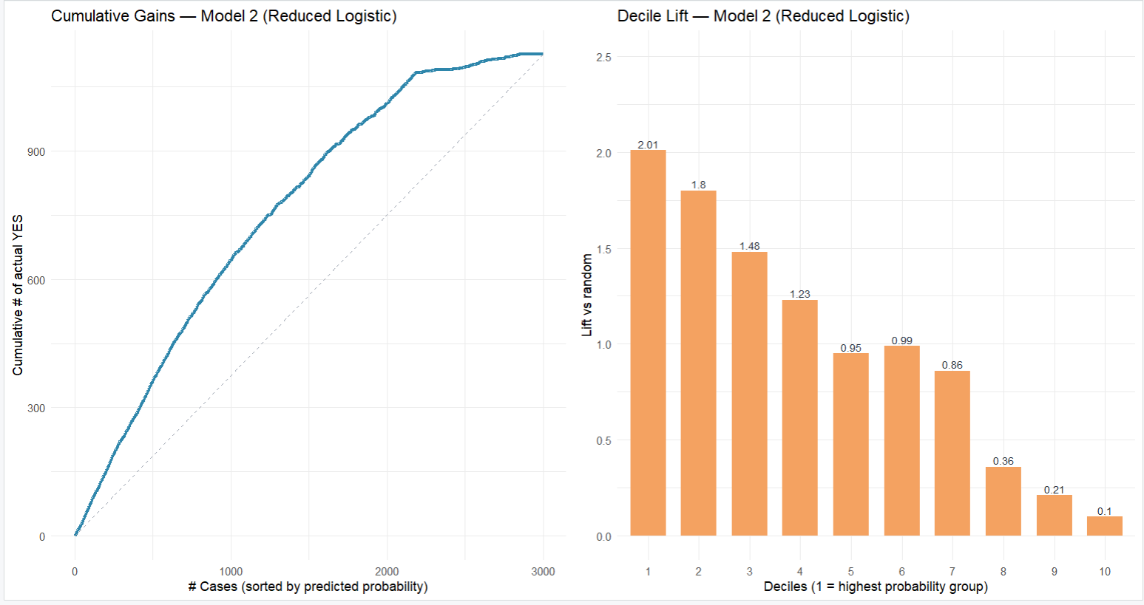

Decile Lift – Full Logistic Regression: Highest top-decile lift (2.19) confirms superior efficiency in prioritizing high-impact voters under limited resources.
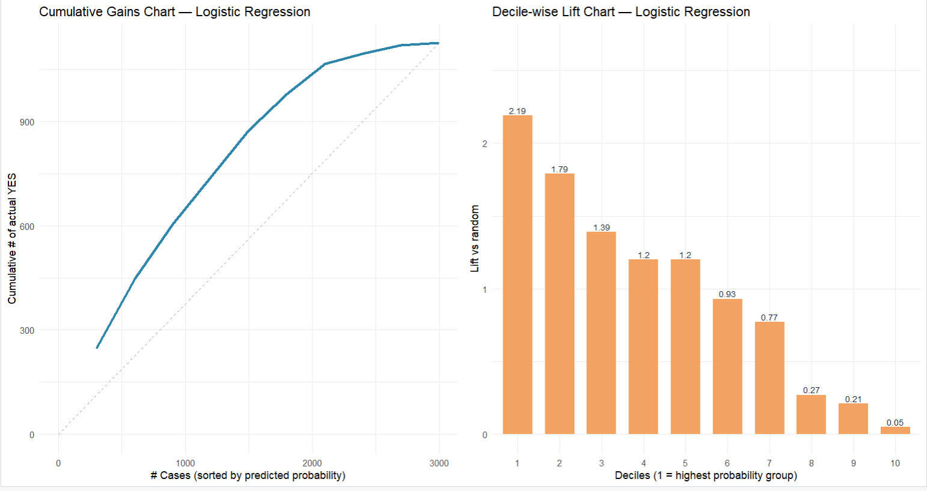

Decision Tree Structure: Party affiliation, eligibility, and age form the key splits, revealing clear voter segments with different persuasion likelihoods

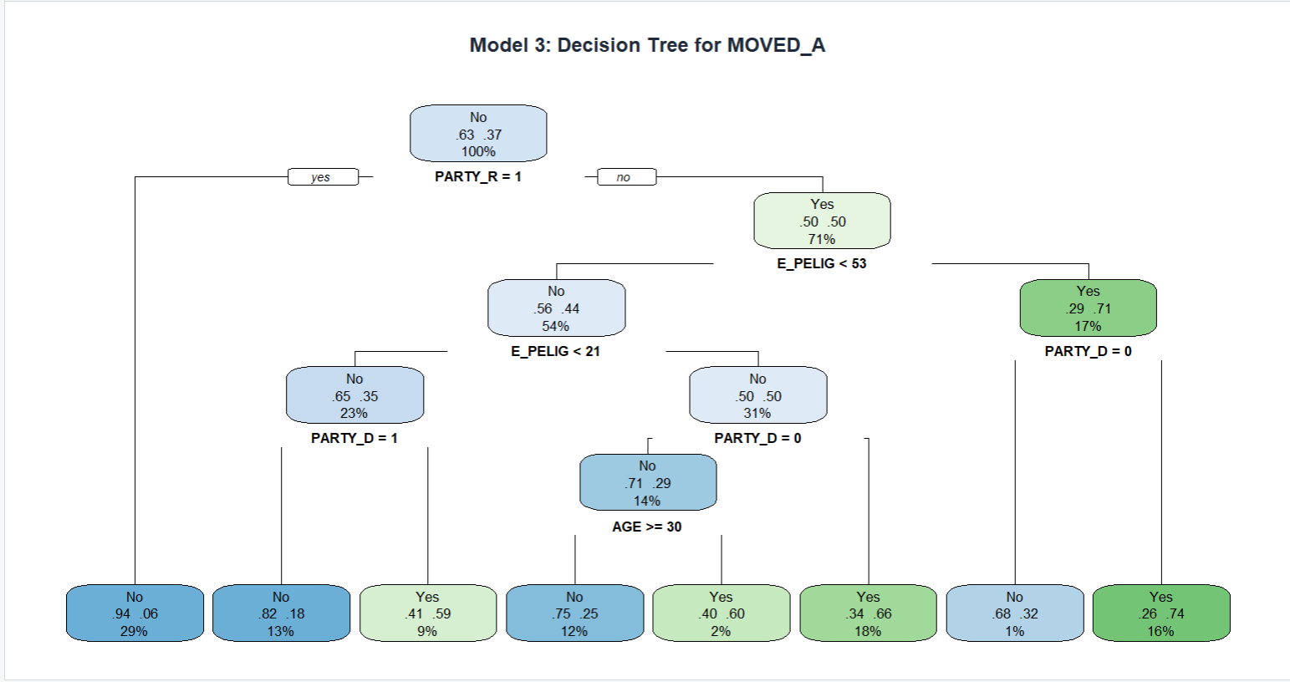

Predictor analysis and variable relevance
To understand which variables actually carry useful signal, each predictor was compared across the two MOVED_A groups. For numeric variables, median values and interquartile ranges were compared between persuaded (1) and not persuaded (0) voters. For binary flags, the persuasion rate within each flag group was calculated. The findings below go from strongest signal to weakest based on how large and consistent the difference between groups was.
Key findings and relationships:
Party affiliation (PARTY_D, PARTY_I, PARTY_R): When MOVED_A is cross-tabulated against the party flags, it is clear that Democratic-registered voters (PARTY_D = 1) are persuaded at a much higher rate compared to Independents or Republicans. The gap is big enough that PARTY_D becomes the first split in the decision tree model. This means party affiliation by itself already divides the voter pool into groups with meaningfully different persuasion probabilities. For targeting purposes, this should be the first filter applied.
Voting history (VPP_, VPR_, VG_*): Voters who participated in recent general elections - VG_08, VG_10, VG_12 = 1- are persuaded at rates above the dataset average of around 37%. This was consistent across every election-year flag that was checked, not just one or two. It makes intuitive sense: someone who votes regularly is probably more open to being contacted by a campaign in the first place. These variables work well as a second layer of targeting after the party has already been used.
Eligibility and propensity scores (E_PELIG, G_PELIG, PP_PELIG, AP_PELIG): Boxplot comparisons show a visible distributional shift in E_PELIG between the two groups - persuaded voters tend to score higher. E_PELIG also has the largest median gap among the four eligibility measures and appears as a splitting variable in the decision tree. These scores seem to capture some mix of civic accessibility and general responsiveness to outreach, which is why they are strong predictors for ranking voters.
Demographic factors (AGE, MED_AGE, REG_DAYS, MED_HH_INC, education indicators): The group differences here are real but smaller compared to eligibility scores and party flags. Persuaded voters tend to be slightly older and come from areas with a bit higher median household income. On their own these variables are not strong predictors, but they add useful detail when differentiating within groups that already share similar party affiliation and eligibility characteristics.
Lifestyle and interest indicators (BOOKBUYERI, RELIGIOUSC, POLITICALC, etc.): Most voters score zero on most of these flags, so it is hard for any single lifestyle variable to show a strong difference between groups. Where non-zero values appear, especially POLITICALC, there is a small positive association with persuasion. These variables are not strong enough to drive targeting decisions on their own but they are still included in the full model because they add some extra context when other signals are similar between voters.
Some variables were removed before modeling, and each one had a clear analytical reason. MOVED_AD and opposite are basically alternate forms of the outcome variable - keeping them would let the model read the answer directly from the data, which inflates performance without any real predictive value. MESSAGE_A_REV and GENDER_M are exact complements of MESSAGE_A and GENDER_F - having both from each pair creates perfect collinearity that stops model estimation from working. OPP_SEX was removed because the values in the dataset did not follow any consistent definition, making the variable impossible to interpret.

Dimension reduction
Before starting to build models, it was necessary to decide whether to apply formal dimension reduction. After removing identifiers and leakage variables, about 75 predictors remained. The question was whether those predictors overlap enough that compressing them into fewer components would help, or whether each variable is distinct enough that it should stay as it is.
PCA was not used because most features are representative of unique and meaningful voter attributes, such as a party registration flag, a specific election year turnout record, an eligibility score, and whether someone received Message A. Rotating those into abstract components would remove the interpretability that makes the findings useful. A campaign manager cannot act on “Component 3.” They can act on “voters with PARTY_D = 1 and E_PELIG above the median.” There is also no modeling requirement pushing toward PCA. Logistic regression and decision trees both handle correlated predictors without issue.
Variable pruning was used instead to remove columns that create structural problems without adding any predictive value. The categories that were pruned:
- The identifier and non-informative features (X, VOTER_ID) were removed because they do not impact persuasion prediction.
- Outcome-leaking features (opposite, MOVED_AD) were removed because they would artificially increase model performance.
- For perfectly collinear features, only one feature from each set has been retained by removing redundant features (e.g., MESSAGE_A and MESSAGE_A_REV, GENDER_F and GENDER_M).
- For features with near-zero variance, they were removed to ensure better numerical stability.
The variables removed are ones that have structural problems, i.e., collinearity, near-zero variance, and outcome leakage. The variables kept are the ones that actually represent meaningful voter characteristics. The final predictor set includes everything related to message framing, voting history, party affiliation, eligibility scores, and demographics, since those are the variables the campaign can actually do something with.

Data engineering and transformation
Minimal data engineering had to be done before using the voter persuasion data for modeling.
- Type conversion: Character variables were turned into factors to ensure consistent handling during modeling.
- Outcome formatting: At the modeling step, the outcome variable MOVED_A was changed into a labeled factor (“Yes” or “No”) to help probability-based evaluation.
Since many binary predictors or bounded numeric scores, normalization or scaling didn’t perform. Also, the chosen models (logistic regression and decision trees) don’t require standardized inputs.

Data partitioning methods
To check how the model performed on new data, a holdout method was applied. This also helped lower the risk of overfitting.
- Training set: 70% of voter records
- Testing set: 30% of voter records
The data was split randomly so both sets would have a similar distribution of the target variable MOVED_A. After the split, we confirmed that the outcome proportions were consistent in both the training and testing sets.

Model selection and justification
The modeling approach was driven by the following business objectives:
- Determine which voters are most likely to be persuaded to prioritize outreach
- Assess whether Message A can enhance persuasion performance across voter segmentation
Models Evaluated
Model 1: Logistic Regression (Full) - baseline model with many predictors, offering rich interpretability with probability estimates that enhance voter ranking and targeting.
Model 2: Logistic Regression (Reduced) - a cleaner version using a smaller set of meaningful predictors (especially MESSAGE_A + party + voting history) but retains relevance and stability for campaigns.
Model 3: Decision Tree (CART) - captures nonlinear relationships and interaction effects. Generates easily interpretable decision rules for voter segmentation and targeting.
Model Evaluation Metrics
- Key Metrics: ROC–AUC, cumulative gains, and decile lift, focusing on ranking and targeting success rather than accuracy itself.
- Training was performed via cross-validation for all models with a holdout test set assessment.
In general, logistic regression models will support transparent, probability-based targeting and messaging evaluations, while the decision tree will provide additional insights into complex voter interaction patterns that are relevant for developing campaign strategies.

Model fitting and performance evaluation
Data split (random holdout):
- Training set: 70% (7,000 records)
- Testing set: 30% (3,000 records)
- Class balance stayed consistent:
Train: Yes = 37.26% , Test: Yes = 37.53%
Models fitted (for MOVED_A = “persuaded by Message A”):
- Model 1: Logistic Regression (Full) - strong baseline, gives probability scores for targeting.
- Model 2: Logistic Regression (Reduced) - smaller, cleaner set of meaningful predictors for stability.
- Model 3: Decision Tree (CART) - captures nonlinear patterns and gives easy decision rules for segment targeting.
Test performance summary:
Model | AUC | Accuracy | Sensitivity (Yes) | Specificity (No) | Lift (Top 10%)
Logistic (Full) | 0.804 | 0.723 | 0.603 | 0.796 | 2.19
Logistic (Reduced) | 0.784 | 0.722 | 0.564 | 0.817 | 2.01
Decision Tree | 0.818 | 0.767 | 0.807 | 0.743 | 2.02

Interpretation:
- Best AUC: Decision Tree (0.818) - strongest at distinguishing who will be persuaded.
- Best early targeting (top 10% lift): Logistic Full (2.19) - the top decile is about 2.19× better than random for finding persuaded voters.
- Reduced logistics perform almost the same accuracy, but trade off some sensitivity for a cleaner, more stable model.
(Note: Tree lift was computed using ranked-probability deciles, since tree probabilities are leaf-based.)

Model’s Performance
This section looks at how each model performs against the campaign’s main decision problem, who to contact first, given limited time, budget, and staff. The focus is not on overall accuracy. What matters here is whether the model can rank voters usefully, so the highest-ranked contacts are the ones most likely to be persuaded. All results are based on the 30% holdout test set (3,000 voters) that the models never saw during training.
10.1 Model comparison and reliability
Three supervised classification models were evaluated:
- Logistic Regression (Full)
- Logistic Regression (Reduced)
- Decision Tree (CART)
The measurement of performance was based on ROC-AUC, accuracy, sensitivity, specificity, and lift of the top-decile, with a specific focus on the metrics that have a direct correlation to campaign targeting worth. The three models exhibit varying performance characteristics that directly influence campaign outreach decisions.
The decision tree had the highest overall discrimination with ROC-AUC = 0.818 and sensitivity = 0.807. That sensitivity means it correctly identifies around 80% of voters who would actually be persuaded, which is valuable if the campaign wants to avoid missing persuadable people. The cost is a lower specificity (0.743), meaning it also flags more voters who would not actually be persuaded, so total contact volume goes up.
The full logistic regression has slightly lower overall discrimination (ROC-AUC = 0.804) but the best top-decile lift at 2.19. In practical terms this means a voter ranked in the top 10% by this model is more than twice as likely to be persuaded compared to a randomly chosen voter. When the campaign has a tight contact budget and the early calls need to count the most, that ranking advantage matters more than broad sensitivity.
The reduced logistic regression performs close to the full version (ROC-AUC = 0.784, lift = 2.01) but uses fewer predictors. Sensitivity drops to 0.564, so it misses more persuadable voters. The tradeoff is a simpler and more stable model that is much easier to explain to non-technical campaign staff. This is the right choice in situations where the model needs to be handed off and used without a data analyst available.
Operationally, a false negative means a missed persuasion opportunity and a false positive means wasted outreach spend. The tree is built for catching more persuaded voters (higher sensitivity) while the logistic model is built for ranking the strongest candidates at the top (higher early lift). All three models perform better than random targeting, which confirms that voter-level data does carry real signal for predicting persuasion.

Model Evaluation
The models are evaluated in terms of how effectively they support the campaign’s two business problems:
1) maximizing return on campaign spending through efficient voter targeting, and
(2) improving message effectiveness without increasing outreach cost.
For the targeting use case, the full logistic regression is the strongest recommendation. The decision tree has better AUC (0.818 vs 0.804), but the logistic model outperforms it at the top of the ranked list with a decile lift of 2.19. That means contacting the top 10% of voters ranked by this model gives more than twice the persuasion return compared to random outreach. When the campaign is in early contact mode with limited budget and staff, early precision matters more than overall recall. The decision tree is more useful as a secondary tool. Its sensitivity of 0.807 is the highest of the three models, which helps when the campaign wants to map out which voter segments are persuadable, rather than rank specific individuals. The limitation is that its lift drops off faster across deciles, so it is not the right primary engine for prioritizing limited contacts. The reduced logistic sits between the two - lift of 2.01, sensitivity of 0.564, and fewer predictors. It performs weaker than the full model, but the advantage is operational simplicity. Fewer predictors, easier to explain, easier to use without specialized support. On the message framing question, the logistic regression models give a direct coefficient estimate for MESSAGE_A, which lets the campaign see exactly how much that framing shifts persuasion probability. The decision tree captures interactions but does not isolate the MESSAGE_A effect as clearly, making the logistic models better for that specific business question.
Given the campaign’s goals of using resources efficiently and improving message effectiveness without raising costs, the full logistic regression is the recommended primary model for voter targeting.

Observations and Conclusions
Key observations:
- The strongest predictors of persuasion are PARTY_D (Democratic affiliation), past general election participation (VG_08, VG_10, VG_12), and eligibility score E_PELIG. Specifically, Democratic-affiliated voters with consistent general election turnout and high E_PELIG scores are the most likely to be persuaded by the campaign message - this group represents the highest-priority outreach targets.

- MESSAGE_A exposure shows a consistently higher persuasion rate compared to voters not exposed to Message A framing. This means that campaign managers should prioritize deploying Message A specifically to moderate-to-high eligibility voters (E_PELIG > 0.5) who have voted in at least two of the last three general elections - this combination produces the greatest lift in persuasion outcome (MOVED_A = 1).

- Demographic and lifestyle factors such as AGE, MED_HH_INC, and BOOKBUYERI play a secondary but meaningful role. Voters aged 35–55 in mid-to-high income households (MED_HH_INC above the dataset median) show a moderately higher persuasion rate. Lifestyle indicators like POLITICALC and BOOKBUYERI further refine targeting within undecided voter segments where behavioral signals alone are insufficient.
Model effectiveness:
- Targeting performance: The Full Logistic Regression model (ROC-AUC = 0.804, top-decile lift = 2.19) means that contacting only the top 10% of voters ranked by the model, approximately 300 voters out of 3,000 in the test set, yields more than twice the persuasion rate compared to contacting 300 random voters. For a campaign with a limited contact budget of 1,000 calls, using this model’s ranked list would be expected to persuade roughly 219 voters versus ~100 from random outreach.

- Operational efficiency: A lift of 2.0–2.19 in the top decile means that the Decision Tree model is best for broad voter discovery (sensitivity = 0.807), while the Full Logistic Regression model is best for precision targeting with limited resources. Campaign field directors should use the Full Logistic model’s ranked probability scores to build their contact list, then apply the Decision Tree’s party/eligibility/age decision rules to segment those contacts into message-specific outreach tracks.

Business value:
- Campaign managers can cut wasted outreach by at least 50% by restricting contact efforts to the top two deciles of the Full Logistic Regression model’s ranked voter list. For example, instead of canvassing all 10,000 registered voters, concentrating on the top 2,000 (20%) is projected to capture over 60% of all persuadable voters in the dataset, a direct, measurable reduction in cost-per-persuasion.

- Message delivery can be optimized without extra cost: the logistic regression coefficient for MESSAGE_A is positive and statistically meaningful, confirming that voters exposed to Message A framing are more likely to be persuaded (MOVED_A = 1). Communications teams should use this finding to standardize Message A as the default outreach script for all high-eligibility, high-participation voter segments identified by the model.

- The Decision Tree’s interpretable splits, rooted on party affiliation, then eligibility score, then age, give campaign managers a clear, rule-based voter profile they can communicate to field staff: “Prioritize Democratic-registered voters under 60 with an eligibility score above the median who voted in the 2012 general election.” This translates the model output into a concrete, actionable targeting rule that staff can apply without needing access to the model software.

